MAPS AND MILLS – OPEN MEETING
Tuesday 24th January 7.30pm at Woosehill Community Hall

We are holding an open meeting to tell you a little of the industrial history of the Emm Brook and show the maps that Roland Ramsdale produced for us. Colin Mitchell has found out a lot about the two mills on the brook. One of them was off Molly Millars Lane near to Finchampstead Road and the other on the Reading Road close to Woosehill. This presentation will also include a short history of the families running the “Little Mill” at Emmbrook.

Roland will present the making of the maps that we show on our web site. He has put in a huge amount of effort in generating these maps from scratch, using aerial photographs. Both of these presentations should be fascinating and we hope you will be able to attend.

Do you have any photographs of the river and its surroundings? We would like to exhibit them at the meeting. Anything showing the riverside area at any time would add to our knowledge of the river and the habitats. If you could lend us something, please email vicechair@emmbrook.org.uk or phone 978 5168.

C F Taylor site – Molly Millars Lane
There is a planning application to build 374 apartments on the site of the former factory. Whatever the planning merits of the application, FOTEB is interested in the future development of the site, as this is where the Emm Brook flows underground in a culvert.

We contacted the Council and the developer asking that any development of the site should include the opening up of the brook, as this will help the bio-diversity of the area and reduce the risk of flooding. Additionally we have met with the planning team at the Council with a view to adopting the principles of our Management Plan into the new strategic plan for the district.

Himalayan Balsam
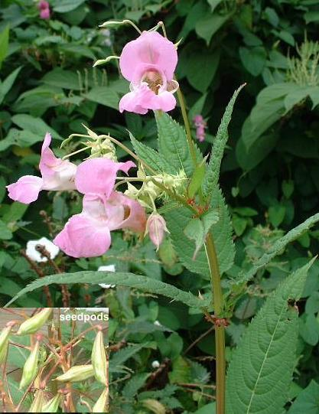
As its name implies, this plant isn’t a native of the UK. It was introduced in 1839 and has escaped to colonise riverbanks and other damp ground. An annual, it can reach 3m high before the seedpods explode scattering seed over a wide area. With thick, hollow stems and pointed, serrated leaves, it has pretty pink or mauve flowers in June and so can be thought of as an interesting plant to have. But it is so invasive that it totally swamps an area leaving no room for anything else – leaving the ground bare in winter.

The banks of the Emm Brook are awash with it and we are going to try to start eliminating it. Last summer a small group went paddling behind the shops in Clifton Road and cleared a short stretch until the water was deeper than our boots! FOTEB is now investing in some waders and other tools and we will have several working parties this June. (Jack Earnshaw)

2005 Breeding Bird Survey
In April-June last year a band of 9 early-rising surveyors carried out a breeding bird survey along 6km of the Emm Brook, running from the M4 to Ludgrove School. Three visits were made to each of 5 survey sections, classifying the habitats in 200m stages and counting the birds seen or heard within each stage. Over 1200 individual birds were counted of 48 species, covering a good range of common residents and summer visitors. There were a few less expected sightings, such as Hobby, Herring Gull, Lapwing and Little Owl. Analysis of the data is ongoing, with the aim of producing a report in the early Spring, which will hopefully spur on the surveyors to repeat the survey annually, building a valuable data-set on the bird biodiversity along the Emm Brook. (Paul Bright-Thomas)

Beavers visit the Emmbrook
On 28th September 1st Woosehill Kingfisher Beaver Colony held its meeting on the riverbanks. Starting at Riverside Walk they crossed the river observing the habitats and discussing what wildlife might live here. The highlight of the session had to be river dipping from one of the bridges. All the boys were eager to find signs of life in the river and spent some time examining the creatures caught in their nets. They found several freshwater shrimps, water mites, a snail and a stickleback. All wildlife was returned to its home at the end of our session. The Beavers enjoyed their visit and were able to use the session towards an activity badge. (Stephanie McKay)
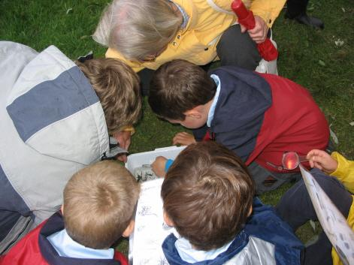

Bluebell Meadows
On Sunday, 16th October in calm warm weather a small group of members explored these quiet meadows just south of Dinton. In the north-east corner is a short reach of the Emm Brook, appearing from a tunnel under Robinhood Lane and disappearing under the M4 into Dinton. I have previously seen a kingfisher here but no luck on this visit. The Brook was flowing freely towards Dinton, between steep banks. The flat meadows stretch westwards to the edge of Winnersh Triangle Industrial Estate with areas of trees and shrubs, and often many rabbits, their burrows visible in the banks along the motorway. Oak, horse chestnut, poplar, hazel, hawthorn, cherry, field maple, alder, willow (including a rather unusual one – we need help to identify this), wild privet, wild rose, brambles and nettles were all identified. Amongst the smaller plants were comfrey, thistle, mullein, ragwort, and centaury. Many must have been planted and there is a wealth of food for the birds and insects. We saw and photographed a lovely orange-brown dragonfly on the fence and there were some butterflies around. The bird life included crow, starling, house sparrow, long tailed tit, chaffinch, jay, magpie, wood pigeon, robin and we heard a woodpecker.

There are two ‘wet’ areas, at this time just reeds and very overgrown but I believe do fill with water – and I have heard they support great crested newts! A strange avenue of willows appears between the two ponds and on the 1883 map it is identified as Mungalls Lane - so some history as well. (Sue Farrington)

Grey Wagtail
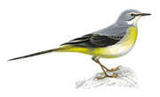
This attractive little bird has been seen along the Emm Brook near the Woosehill roundabout. This seems an appropriate place as the books say it can be found near weirs and we know there is one just south of where the Brook goes under the Spine Road. Like all the wagtails it is constantly moving, flicking its long tail and searching for food along the stream banks. It prefers rivers fringed by broadleaved trees, which may provide caterpillars and other insects. It runs and walks and has a dipping flight. It is mainly grey with yellow underparts that go right round the tail. The male has a lovely black throat in breeding plumage. Not much of a singer, it has a number of calls. It tends to be seen more in the south in autumn so keep a look out along the Emm and let us know if you spot it. (Sue Farrington)

Wokingham’s Veteran Trees
Veteran trees are a valuable part of Wokingham’s heritage. The town is home to many of these extremely old trees, some of which grew in the original Windsor Great Park. The “Wokingham Town Veteran Tree Project” was commissioned by the Wokingham Society in partnership with Wokingham District Council and BTCV and was launched on November 30th.

Volunteers are needed to help identify and survey all trees that are over 1 metre in diameter. This information will then be entered onto an electronic map to show where the trees are located. Where suitable, the Council will look at measures, such as Tree Preservation Orders, to protect the trees for the future.

The first volunteer training day is to be held on Saturday January 21st 2006 at St Pauls Parish Rooms. Contact BTCV’s Andy Noyes, the project liaison officer, on 0118 947 5049, at a.noyes@btcv.org.uk or Wokingham Town Veteran Tree Project, BTCV, 16 Bridge Street, Caversham, Reading RG4 8AA

Emmbrook Mill
You’ll hear more about the history of the mills at the meeting on 24th January. But here are a couple of snippets about this mill that was just north of the Reading Road by the Woosehill roundabout.
- It was called The Little Mill on the earliest maps.
- Devonians John and William Wescott ran it from the 1860s as a paper mill.
- In 1841 William Watmore ran Little Mill. But in 1851 he is described as a publican.
- The leat, used to feed the waterwheel, is now mostly buried under the Woosehill Spine Road.
- There appear to be no photographs of the mill itself.

2006 Outline Programme
24th January – public meeting on maps and history
15th May – AGM (Town Hall 7.30pm)
March – Spring Walk
April – Easter Egg Hunt
May – Pond Dip and sampling of river creatures
June – Breakfast Bird Walk
June – Balsam removal (2 sessions)
July – Balsam removal (2 sessions)
August – Evening Walk
September – Wildlife Treasure Hunt
October – Autumn Walk
More details and the dates in the next edition.

